**4.3 Container Deployment Using Docker Swarm**

**Note: Step are same as practice project 4.2 till 5**

1. Clone the given git repo Using command (I used repo that gave in assisted doc)

git clone <https://github.com/Anuj1990/Docker.git>  
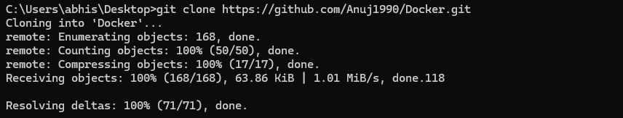

1. Now go to the cloned repo and then build the image using the below command:  
   docker build -t phpcode  
     
   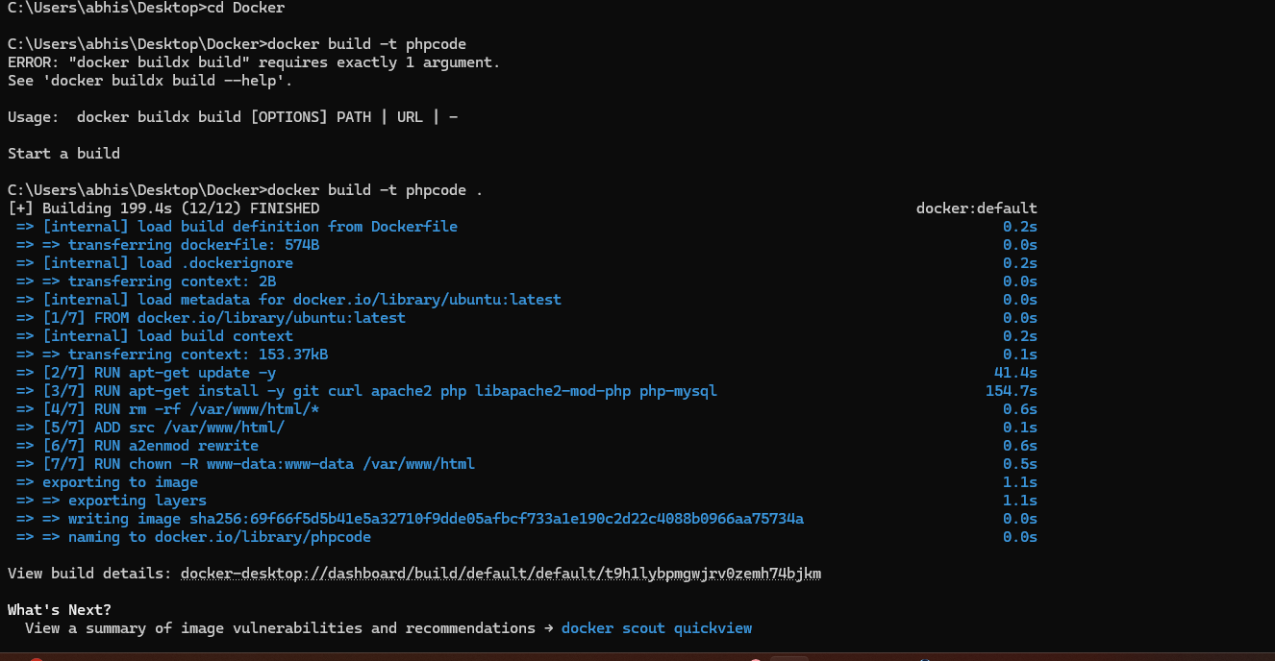
2. Now we can see the build image using the below command:

docker images

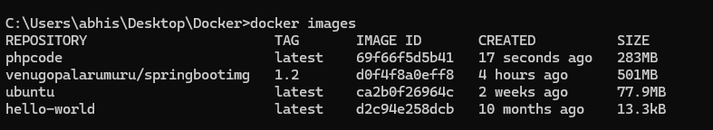

1. Now run the image using the below command:

docker run -d --name phpcode -p 80:80 phpcode  
  


1. To push the image to docker hub use the below command:
   1. docker login
   2. docker tag phpcode coutabhi/myphpcode:1.0
   3. docker push coutabhi/myphpcode:1.0

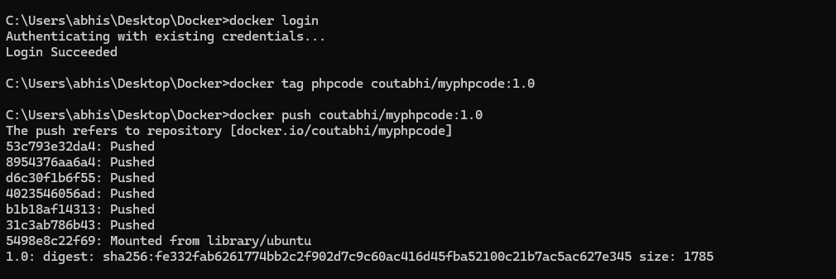

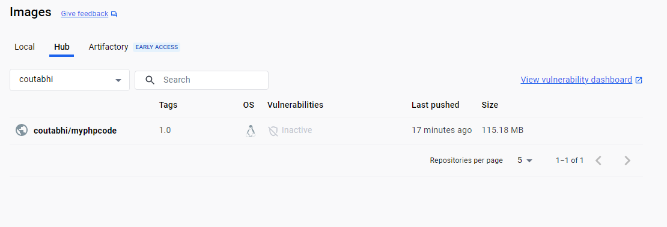

1. Initialize a docker swarm cluster using commands below:
   1. docker swarm init
   2. docker node

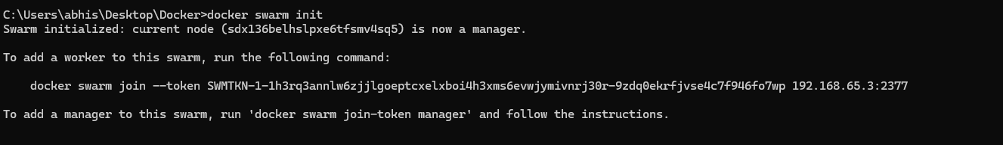

1. Deploy the custom image on the docker swarm cluster
   1. docker service create -p 80:80 –name webserver phpcode
   2. docker service ls
   3. curl localhost

